**We thank our sponsors …**

**We would like to thank all of our sponsors, including Bay Colony Group, a leader in providing high-quality civil engineering, land planning, land surveying and construction services.**



**Bay Colony Group**

**4 School Street, Foxborough, MA**

**www.baycolonygroup.com**

**Join us at BAR LOUIe**

**Once again, we are excited to partner with Bar Louie at Patriot Place where our patrons will enjoy good food and entertainment following the race! We will host snacks for families and a children’s buffet; and we will distribute all awards and raffle prizes at the restaurant.**

***At least 1 in 59 children will be diagnosed with an autism spectrum disorder this year!***

**We thank Bar Louie for working with us to enhance our fundraising efforts and look forward to hosting our event at their restaurant again this year!**

**Whether you run or walk or volunteer… whether you choose to become a sponsor or simply want to come to the party – we do hope you will join us to raise funds and awareness in support of individuals living with autism and their families!**

**Please visit** [**www.baileysteam.org**](http://www.baileysteam.org)

**for more information about how to support BAILEY’S TEAM for AUTISM**



**Please join us for our ninth annual**

**Bailey’s Team for Autism**

**164 Westside Avenue**

**North Attleboro, MA 02760**

***5k [3.1 miles] - Professionally Measured***

***USATF Certified Course***

**Rain or Shine**

**Sunday, March 29, 2020**

**The Race will begin at Schneider Electric**

**38 Neponset Avenue, Foxboro, MA**

**8:30 am Registration**

**10:00 am Run Start & Family Walk**

**11:00 am Awards Presentation &**

**After Party**

**Bar Louie - Patriot Place**

***Good food, good fun & lots of prizes!***

**Bar Louis – 232 Patriot Place, Foxboro**

**RUNNERS please visit** [**www.baileysteam.org**](http://www.baileysteam.org)

**To register for this event!**

***BAILEY’S TEAM for AUTISM is a non-profit organization raising funds and awareness in support of individuals living with autism and their families, with a focus on research, education and programming.***

**Bailey’s team FOR AUTISM**

**Autism is a complex neurological disorder and impairs a person's ability to communicate, relate to others and process information.**

**In September of 2001, shortly after Bailey was diagnosed with autism, our family participated in the first *New England Walk for Autism*. We invited our family and friends to join us at this special event and as a result of the outpouring of love and support felt by our family on this bittersweet day, we were inspired to form BAILEY’S TEAM.**

**BAILEY’S TEAM was incorporated in 2008 and has gone on to raise over $1.2 million in support of autism research, awareness, education and programming.**

**We strive to make a positive impact on individuals living with autism spectrum disorders and their families. It is important that we educate our community about our loved ones with autism and the need to value and support them!**

**We hope you will join our team…**

* **Register ASAP to RUN or WALK for AUTISM**
* **Attend any of our upcoming fundraising events**
* **Sponsor an event with a cash or in-kind donation.**
* **Join our mailing list to receive our semi-annual newsletter.**
* **Make a tax-deductible donation to:**

**BAILEY’S TEAM for AUTISM**

**You can accomplish any of the above and become a part of our team by visiting our website:**

[**www.baileysteam.org**](http://www.baileysteam.org)

**BAILEY’S TEAM is a 501(c)(3) non-profit organization allocating 90% of the dollars we raise directly to organizations that support individuals living with autism and their families.**

If you have any questions or would like more information, please contact Sammi Robertson at sammirobertson@comcast.net.

**Bailey’s Run for AUTISM**

**Location & ROUTE:**

**The run will start and finish in front of Schneider Electric at 38 Neponset Avenue and will continue right onto Chestnut Street then onto Mechanic Street and up Baker returning to Chestnut and Neponset back at the start. This event is RAIN or SHINE!**

**Course:**

**Fast, Flat course to encourage good race time!**

**Bailey’s Run Registration Fee:**

**Entry fee is $30 if pre-registered by March 10th. All registrations received after March 10th – on line or on race day – are $35 and registration ends at 9:45 on site (March 29th).**

***[There will be no refunds if we must cancel due to severe weather conditions.]***

**Walk Registration & Details:**

**Participation is free but registration is required Please note that ALL walkers must sign a waiver and adults must sign on behalf of their child(ren).**

**T-Shirts:**

**T-shirts are free for the first 150 registered *runners.* Register early for best size selection.**

**Parking:**

**There is plenty of parking available at both Schneider Electric and at Bar Louie, Patriot Place where we ask you to join us for the awards presentation and after party.**

**Bailey’s Run Prizes:**

**Prizes will be awarded to the first three overall winners (male & female) and the top male and female in the following age groups: 12 & under, 13–18, 19–29, 30–39, 40–49, 50–59, 60+.**

**Refreshments:**

**Light refreshments will be provided on site during registration and there will be complementary snacks at Bar Louie along with a complementary Children’s Buffet.**

**RAFFLE:**

**There will be exciting raffle prizes available to win with proceeds to benefit individuals living with autism spectrum disorders and their families!**

**course map**

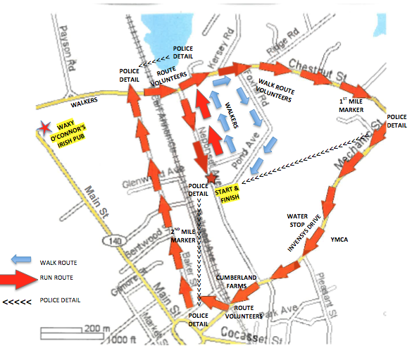

* **Start at guard shack one at Schneider Electric and go down Neponset Avenue towards Chestnut Street**
* **Take a right on Chestnut Street following to traffic lights**
* **Take a right on Mechanic Street following to railroad tracks**
* **Take a right on to Railroad Avenue**
* **Take a left on to Bird Street**
* **Take a right on to Baker Street to the end**
* **Take a right on to Chestnut Street**
* **Take a right onto Neponset Avenue back to starting line**

**Walkers are encouraged to walk the designated one (1) mile route from the race start in order to return in time to cheer on the runners, and then drive to Bar Louie for the after party.**

**If walkers choose to walk 3.1 miles, please note that all participants will be at Bar Louie at the time you arrive at the finish… we do hope you will join us for the fun!**

|  |
| --- |
| **To register for this event, please visit**  [**www.baileysteam.org**](http://www.baileysteam.org) |